

Year 7 Science
Earth & Space 2 Test

SECTION 1: MULTIPLE CHOICE (1 mark each)
Circle your answer on the multiple choice answer sheet.

The first six questions are about the following diagram of the structure of the Earth.
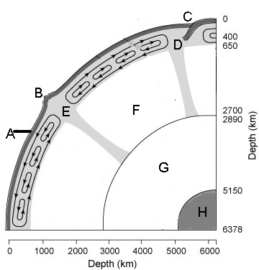

- The part of the Earth that is labelled A is called the
  - crust.
  - mantle.
  - magma.
  - core.

- The solid inner core is labelled
  - E
  - F
  - G
  - H

- The area that is labelled D is called
  - the subdivision.
  - the subduction zone.
  - the expansion zone.
  - the unstable zone.

- You would find a lot of earthquakes and volcanoes around
  - A
  - B
  - C
  - D
- The thickness of the liquid outer core is approximately
  - 2050km
  - 2260km
  - 2890km
  - 5150km

- The thinnest layer of the Earth is the
  - crust.
  - mantle.
  - outer core.
  - inner core.

- The gas that makes up about 78% of the air in the Earth’s atmosphere is
  - nitrogen
  - oxygen
  - carbon dioxide
  - argon

- The upward thrust of an object floating in water is known as
  - pressure
  - friction
  - gravity
  - buoyancy

- Water vapour in the air is known and measured as
  - snow
  - humidity
  - wind
  - hail

- The layer of atmosphere closest to the Earth and containing about 75% of the air is the
  - thermosphere
  - ionosphere
  - troposphere
  - stratosphere

SECTION 2: WRITTEN
Write your answers on the lined paper provided.

- Give an example of how people using natural resources can change (8 marks)

- the soil.

- the landscape.

- the water.

- the atmosphere.

- Label the arrows (1 - 5) below showing the movement of air to form a sea breeze (5 marks)
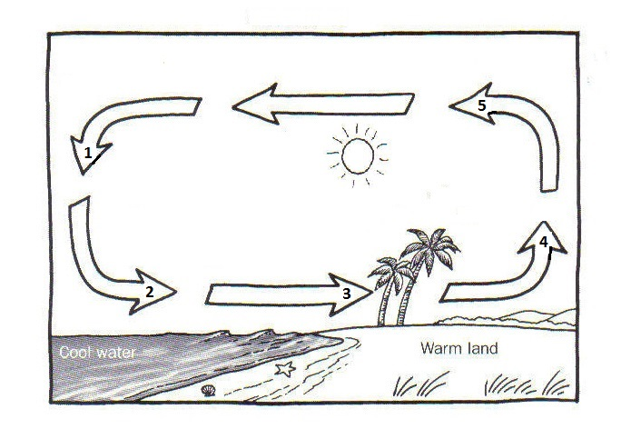

- Briefly describe how heat is trapped in the Earth’s atmosphere causing a greenhouse effect. (2 Marks)

END OF TEST (OUT OF 25 MARKS)

